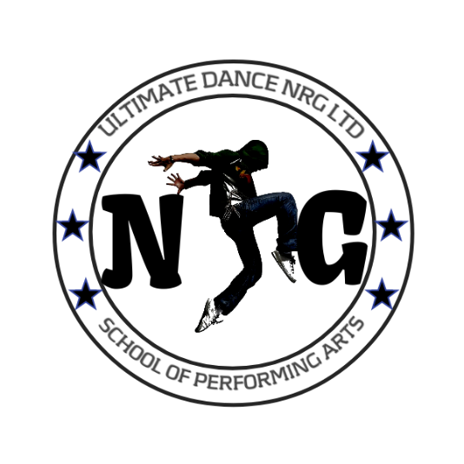

ULTIMATE DANCE NRG LTD

FEES & INFO

Company: 08187352 Branches: Hornchurch, Basildon, Leigh On Sea.

Tel : 07950 475476
Email: admin@ultimatedancenrg.co.uk INFO & T&C’S SEPTEMBER 2025/2026
www.ultimatedancenrg.co.uk

Registration

Welcome to Ultimate Dance NRG! We are delighted that you will be joining our classes in either Hornchurch, Basildon, Or Leigh on Sea. Please find information on uniform, term dates & fees, along with useful social media links to follow and keep up to date!

Please complete your digital registration form, in class, or by visiting www.ultimatedancenrg.co.uk/enrol

Fees & payments

On reverse you will find a list of classes, with monthly/half termly fees listed. Please ensure you review the terms of payments, and payment methods accepted. Any queries, please speak to a member of staff.

Uniform

A UDNRG T-shirt is required to be worn for all of our classes (excluding adults). There are additional items such as jumpers, sweatshirts, long sleeved tops, vests etc. Please visit www.ultimatedancenrg.co.uk to view our shop.

Term dates

Please be advised classes only operate during the school term. Additional rehearsals, school holiday workshops and events take place during school breaks.

September 6th (October Half term 27th-November 2nd)
Return November 3rd (Christmas break December 21st – January 2nd)
Return January 5th (February half term 16th-22nd)
Return January 23rd (Easter break March 30th- April 12th)
Return April 13th (May half term 25th-31st)
Return June 1st ( Summer break 19th July)

Information correct time of printing. Updates will share at class and on social media pages.

KEEP UP TO DATE WITH NEWS AND INFORMATION- JOIN US ON SOCIAL MEDIA!

Facebook: ‘Like’ Ultimate Dance NRG ‘Friend request’ Ul Timate Dancer
Instagram: Follow Ultimate Dance NRG

